|  |
| --- |
|  |
| Unit 5: Integral Applications |
|  |

Our Learning Goals:

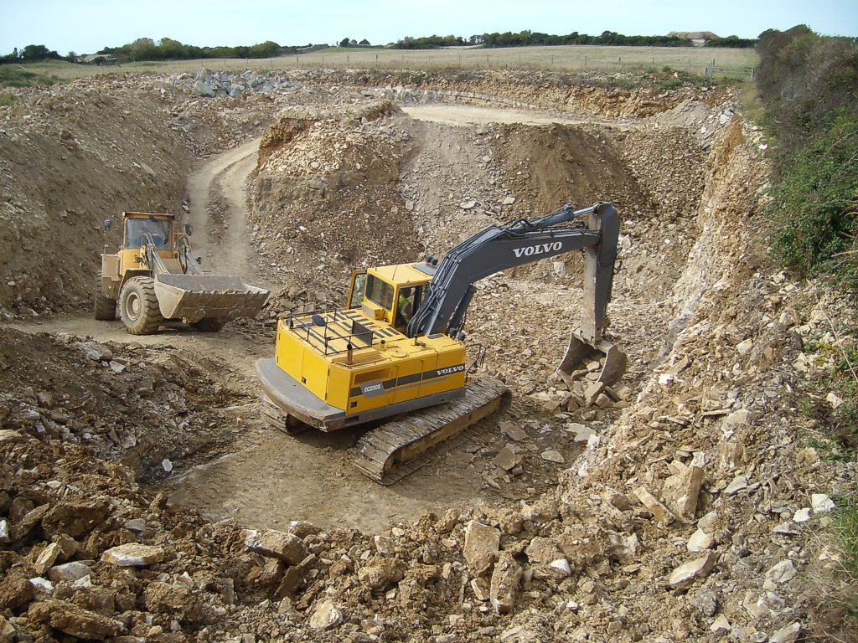

# Sample Problem:

The rate in tons per hour at which rock is being removed from a quarry can be modeled by the function $W\left(t\right)=7\sin{\frac{πt}{5}}$ where $0≤t≤10.$ Find the amount of rock removed during this ten hour period.

|  |
| --- |
|  |
| Additional Support:  * Check the teacher web page and Canvas page for notes, activities, and assignments. * Search the topic on the web. We recommend using Khan Academy and CollegeBoard Student Resources. * Attend tutorials. |

**We will:**

* Use integration to calculate the area under a curve and the area between two curves.
* Use integration to calculate the volume of a solid of revolution.
* Use integration to calculate the volume of a solid with known cross sections.
* Use integration to measure accumulation.
* Use the concepts of differentiation and integration in conjunction in real-world problems.
* Apply the Fundamental Theorem of Calculus graphically and algebraically.

|  |
| --- |
|  |
| Why do we study this?   * Integrals provide us a way to add up change. * Integration allows us to quantify accumulation in a variety of situations. * As long as we can model how something is changing, we can then use integration to determine that change and even predict outcomes such as population for the future. |
|  |

How we will show what we have learned…

|  |  |
| --- | --- |
| Formative Assessments | Summative Assessments |
| Ongoing formative assessments during lesson and homework activities will help in monitoring learning and providing feedback for students. | * Summative assessments to measure learning at the end of concepts will include teacher-made tests and a district common assessment, which includes multiple choice and free response questions. |